Code:

create table publisher(

name varchar(30),

address varchar(50),

phone varchar(10),

primary key(name));

create table book(

book_id int,

title varchar(30),

publisher_name varchar(50),

pub_year varchar(30),

primary key(book_id),

foreign key(publisher_name) references publisher(name) on delete cascade) ;

create table book_authors(

book_id int,

author_name varchar(30),

primary key(book_id,author_name),

foreign key(book_id) references book(book_id) on delete cascade);

create table library_branch(

branch_id int,

branch_name varchar(30),

address varchar(50),

primary key(branch_id));

create table book_copies(

book_id int,

branch_id int,

copies int,

primary key(book_id,branch_id),

foreign key(book_id)references book(book_id) on delete cascade ,

foreign key(branch_id)references library_branch(branch_id) on delete cascade);

create table card(

card_no int,

primary key(card_no));

create table book_lending(

book_id int,

branch_id int,

card_no int,

date_out date,

due_date date,

primary key(book_id,branch_id,card_no),

foreign key(book_id) references book(book_id) on delete cascade,

foreign key(branch_id) references library_branch(branch_id) on delete cascade,

foreign key(card_no) references card(card_no) on delete cascade);

INSERT INTO publisher VALUES ('MCGRAW-HILL','9989076587','BANGALORE');

INSERT INTO PUBLISHER VALUES ('PEARSON', '9889076565', 'NEW DELHI');

INSERT INTO PUBLISHER VALUES ('RANDOM HOUSE', '7455679345', 'HYDERABAD');

INSERT INTO PUBLISHER VALUES ('HACHETTE LIVRE', '8970862340', 'CHENNAI');

INSERT INTO PUBLISHER VALUES ('GRUPO PLANETA','7756120238', 'BANGALORE');

INSERT INTO BOOK VALUES ('1','DBMS', 'MCGRAW-HILL','JAN-2017');

INSERT INTO BOOK VALUES ('2','ADBMS', 'MCGRAW-HILL','JUN-2016');

INSERT INTO BOOK VALUES ('3','CN', 'PEARSON','SEP-2016');

INSERT INTO BOOK VALUES ('4','CG', 'GRUPO PLANETA','SEP-2015');

INSERT INTO BOOK VALUES ('5','OS', 'PEARSON','MAY-2016');

INSERT INTO BOOK_AUTHORS VALUES ('1','NAVATHE');

INSERT INTO BOOK_AUTHORS VALUES ( '2','NAVATHE');

INSERT INTO BOOK_AUTHORS VALUES ( '3','TANENBAUM');

INSERT INTO BOOK_AUTHORS VALUES ('4','EDWARD ANGEL');

INSERT INTO BOOK_AUTHORS VALUES ('5','GALVIN');

INSERT INTO LIBRARY_BRANCH VALUES ('10','RR NAGAR','BANGALORE');

INSERT INTO LIBRARY_BRANCH VALUES ('11','RNSIT','BANGALORE');

INSERT INTO LIBRARY_BRANCH VALUES ('12','RAJAJI NAGAR','BANGALORE');

INSERT INTO LIBRARY_BRANCH VALUES ('13','NITTE','MANGALORE');

INSERT INTO LIBRARY_BRANCH VALUES ('14','MANIPAL','UDUPI');

INSERT INTO BOOK_COPIES VALUES ( 1, 10,10);

INSERT INTO BOOK_COPIES VALUES ( 1, 11,5);

INSERT INTO BOOK_COPIES VALUES ( 2, 12,2);

INSERT INTO BOOK_COPIES VALUES ( 2, 13,5);

INSERT INTO BOOK_COPIES VALUES ( 3, 14,7);

INSERT INTO BOOK_COPIES VALUES ( 5, 10,1);

INSERT INTO BOOK_COPIES VALUES ( 4, 11,3);

INSERT INTO CARD VALUES (100);

INSERT INTO CARD VALUES (101);

INSERT INTO CARD VALUES (102);

INSERT INTO CARD VALUES (103);

INSERT INTO CARD VALUES (104);

INSERT INTO BOOK_LENDING VALUES ( 1, 10, 101,'01-JAN-17','01-JUN-17');

INSERT INTO BOOK_LENDING VALUES ( 3, 14, 101,'11-JAN-17','11-MAR-17');

INSERT INTO BOOK_LENDING VALUES ( 2, 13, 101,'21-FEB-17','21-APR-17');

INSERT INTO BOOK_LENDING VALUES ( 4, 11, 101,'15-MAR-17','15-JUL-17');

INSERT INTO BOOK_LENDING VALUES ( 1, 11, 104,'12-APR-17','12-MAY-17');

select * from publisher;

select * from book;

select * from library_branch;

select * from book_copies;

select * from card;

select * from book_lending;

SELECT B.BOOK_ID, B.TITLE, B.PUBLISHER_NAME, A.AUTHOR_NAME, C.COPIES, L.BRANCH_ID

FROM BOOK B, BOOK_AUTHORS A, BOOK_COPIES C, LIBRARY_BRANCH L

WHERE B.BOOK_ID=A.BOOK_ID

AND B.BOOK_ID=C.BOOK_ID

AND L.BRANCH_ID=C.BRANCH_ID;

SELECT CARD_NO

FROM BOOK_LENDING

WHERE DATE_OUT BETWEEN '01-JAN-2017' AND '01-JUL-2017'

GROUP BY CARD_NO

HAVING COUNT (*)>3;

delete from book where book_id=3;

CREATE VIEW V_PUBLICATION AS

SELECT PUB_YEAR

FROM BOOK;

select * FROM V_PUBLICATION;

CREATE VIEW V_BOOKS AS

SELECT B.BOOK_ID, B.TITLE, C.COPIES

FROM BOOK B, BOOK_COPIES C, LIBRARY_BRANCH L

WHERE B.BOOK_ID=C.BOOK_ID

AND C.BRANCH_ID=L.BRANCH_ID;

select * FROM V_BOOKS;

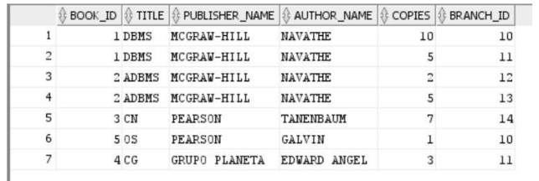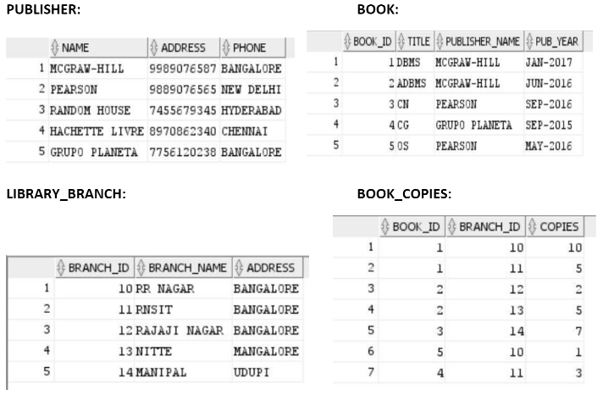**CARD** **BOOK LENDING**

**CARD** **BOOK LENDING**

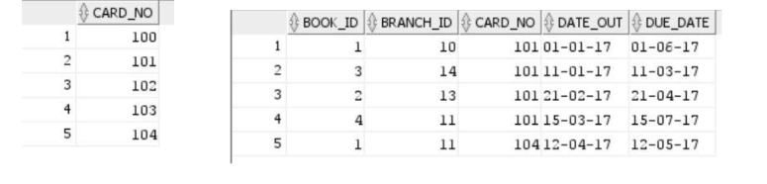

QUERY

1



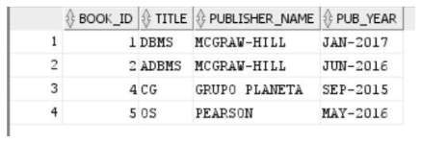QUERY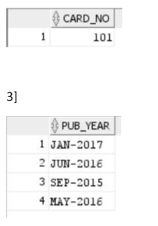 2

QUERY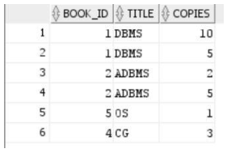 4

QUERY 5

